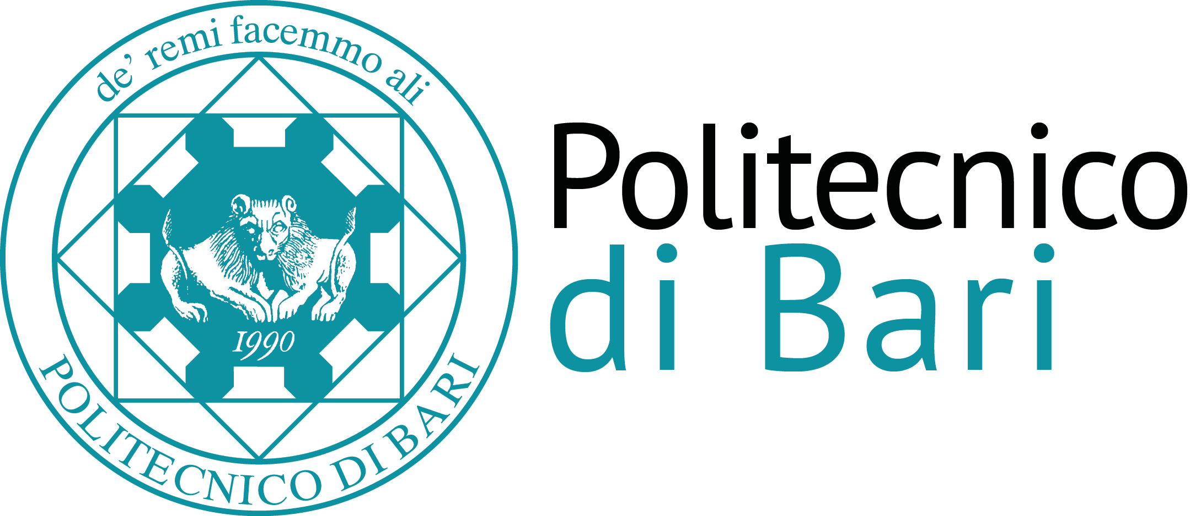

Scuola di Dottorato del Politecnico di Bari

Ph.D. School

Multidisciplinary approach to solving complex environmental problems
CFU 2 (16 ore)
SSD: ING-IND/22, ICAR/03 and ICAR/02
Abstract: Environmental issues are generally complex and, in most cases, require multidisciplinary skills. The optimal solution is the result of a broader evaluation which affects more thematic areas such as environmental, economic and social, paradigm of sustainable development. Additionally, regarding a fixed environmental matrix, such as water, it may involve more professional profiles, from the chemical to the biologist, from the engineer to the physical.
In this context, the course aims to present and analyse examples of multidisciplinary approaches applied to solving complex environmental problems. The presence of a total environment, intended as presence of different thematic areas connected to each other, is the common element in all the case studies addressed.
Program: In the specific, the following issues will be addressed: (i) Use of renewable energies for wastewater treatment and reuse in agriculture; (ii) Remediation of contaminated soil, the case study of the “Terra dei fuochi” in the Campania Region; (iii) Assessment of public perception in support to social acceptance of technological solutions: the case study of actions concerning the water and solid waste minimization implemented in the island of Favignana (Egadi Islands, Sicily); (iv) Siting of the municipal solid waste treatment and disposal facilities in the context of industrialized countries.
The various case discussions will emphasize experiences in research conceptualization, project design and execution, main findings, policy advice and surplus value, and difficulties met. Conclusions and recommendations will be presented about the practice of multidisciplinary research. Finally, some challenges for research and development about environmental sustainability will be discussed.

