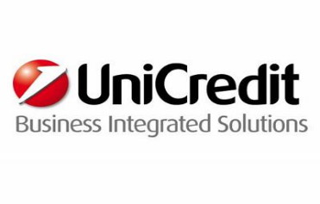

Junior Software Developer - Internet & Direct Channels
Vacancy Type: Graduate
Job Area: Information Technology
Location: Milano

Area description
UniCredit Business Integrated Solutions (UBIS) is an ICT company that operates on a global level as the main ICT service provider for UniCredit. With 19 locations in 8 European companies, UBIS is the provider for all technological and organisational solutions.
Function description
The Commercial Banking Mature Markets Business Line provides IT and Operations services enabling the UniCredit Bank to operate in so-called “mature” markets, that is, Italy, Germany, Austria and the Czech Republic within the Multichannel & Core Banking, Credits and Securities Areas.
In relation to “Omni Channels” services, the Business Line provides ICT services for internet and mobile banking, for operative CRM, for Business Intelligence and ICT/Operations services for Cash Management/Cash Branches Transactions.
Job description
The criticality and importance of the applications used by UniCredit Group Bank Customers and the significant investment that our Group is putting in the area of Omni Channels, are defining this area as one of the most strategic and differentiated in IT of UniCredit.
By using the most modern web based development technologies / frameworks, mainly based on java, such as application Portal Servers, Mobile Platforms, HTML5, Ajax and the collaboration technologies such as Agile, you will have the opportunity to be involved in the following projects:
- functional enrichment of the multichannel platforms that already exist
- renewal of the user experience of digital channels, by maximising the strategies and creating synergies for the three countries as internal clients
- real and direct contribution to the stabilization of the applications, in terms of reliability, resilience and incidents.
What we expect from you
- Collaboration and team work aptitude
- Good level of english (written and spoken)
- Problem solving
- Project management skills
Desired skills required:
Degree in Engineering, Informatics, Mathematics, Physics
- Deliver high quality software
- Pair programming and code review activities
- Proactive identification of service disruptions / continuous monitoring to ensure defined SLAs
- Front-end incident management and resolution (analysis and troubleshooting)
- Back-end incident management and resolution (analysis and troubleshooting)
What we offer to you
If you are looking for an international career in the Technology sector, UniCredit Business Integrated Solutions is the right place for you! You will be challenged with an unique experienced to foster your charisma and creativity, technical competences but also team spirit and continuous learning attitude.

Entry date: 01/03/2016
Contract Type: Apprenticeship
“Please apply to: https://career012.successfactors.eu/career?company=Unicredit “

