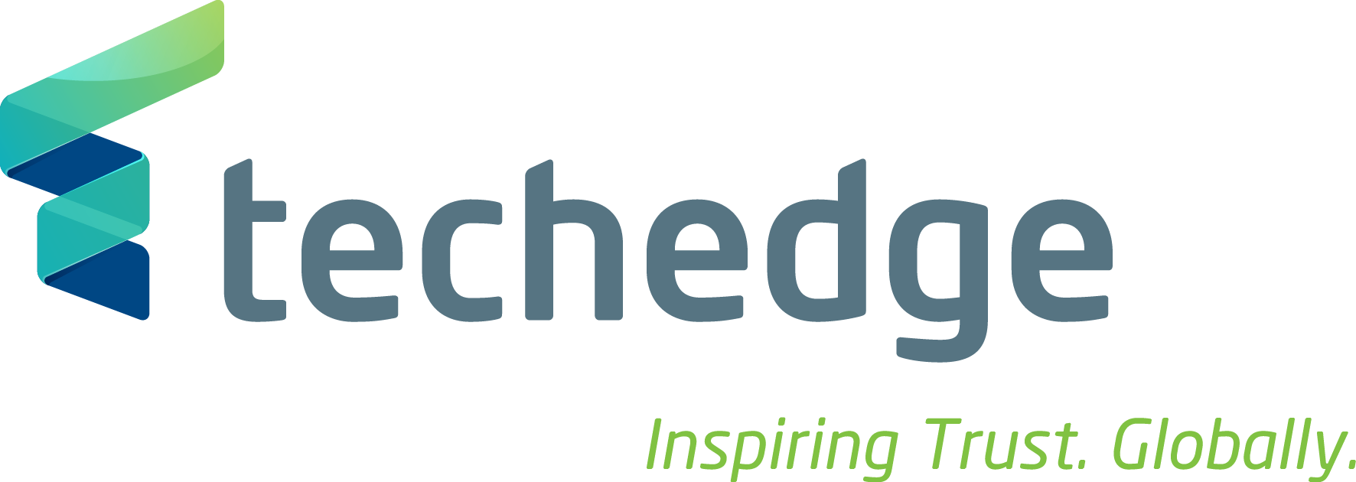
Techedge is an Italian multinational technology consulting company. We're experiencing relentless growth, we now have 25 global offices and we draw on over 1300 professionals. We were just 36 in 2004! We help corporations leverage on IT to understand challenges, solve them and improve results. Hence, other than on business processes we work on Industry 4.0, the Internet of Things and Big Data. Our clients are leading multinational companies in all the industrial sectors.
A career with us means professional development in a supportive environment where you'll meet people with exceptional competences and enthusiasm. Careers with us can be fast-track for those who prove driven, entrepreneurial and competent. Our global scale means that a career with us can very often be international. We offer a competitive salary and permanent contracts from the very start. We have a huge community of Computer Science and Engineering graduates working with us and achieving excellent results! We are interested in meeting both Bachelor and Master graduates and students.

We recruit graduates to join as IT Consultants

Il lavoro:
What does a Consultant do? You'll be assigned to a team working on a client issue. You'll never be alone: you'll learn on the job thanks to Pair Programming, to our Inside Tracks and to the team's daily Scrum Meetings. You'll slowly become an expert on a range of components, products and processes. You'll work on a variety of industries, hence, you'll understand how business processes work, what clients need and how we keep them happy. By the end of your tenure as Consultant you'll have decided whether you are more inclined to be a technology Guru or a hybrid business and IT consultant. It will be up to you.

Requisiti:
To apply you must:
- Be a Computer Science Engineering graduate
- Be happy to work in a team

Skills/competenze:
- Possess good communication skills
- Fluent or native Italian
- Working knowledge of English

Tipologia contrattuale:
contratto a tempo indeterminato

Sede di lavoro: Milano/Roma

Per candidarsi:
inviare il proprio cv aggiornato con voto di laurea a: deborah.zagari@techedgegroup.com inserendo in oggetto “Rif. Contatto Ufficio Placement Politecnico di Bari” entro il 15 settembre 2017
Il CV dovrà contenere l’autorizzazione al trattamento dei dati personali ai sensi del D. Lgs. n. 196/2003 ed attestazione di veridicità ai sensi del DPR n.445/2000.

Il presente annuncio è rivolto ad ambo i sessi, ai sensi della normativa vigente.

