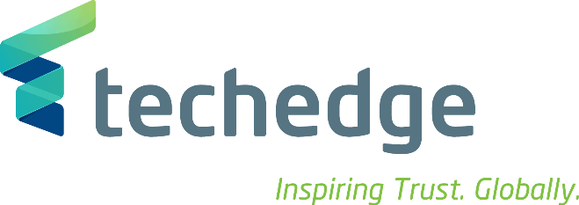

Management Engineering as IT Consultant – Milan office
Techedge is an Italian multinational technology consulting company.
We help corporations improve their business using the latest technology. Put simply, we allow them to leverage on IT to understand challenges, solve them and improve results. We work on Big Data, Industry 4.0, the Internet of Things and corporate business processes. Our clients are leading multinational companies in all the industrial sectors.
We’re experiencing relentless growth, we now have 25 global offices and we draw on over 1300 professionals. We were just 36 in 2004 when we started out!
A career with us means ample room for professional development in a friendly and supportive environment where you’ll meet people with exceptional competences and passion. Our impressive growth means that careers with us can be fast-track for those who prove driven, entrepreneurial and, of course, competent. Our global scale means that a career with us can very often be international.
We are seeking graduates to join as IT Consultants in our Milan office.
We’re looking for management engineers who know business processes and want to become an expert on technology applied to business. Our job is to understand how each different client company has set up their processes and to advise them on the best use of technology to support their specific processes.
What does a Consultant do? You’ll be assigned to a team working on a complex client issue in one of the fields above. In your tenure as a Consultant you’ll work on a variety of industries, hence, you’ll have a great grasp of how different companies deal with their core processes. In the meantime, you’ll become an expert on technology applied to business. Interested?
To apply you must:
• Laurea in ingegneria gestionale
- Have strong analytical skills
• Be happy to work in a team
• Possess good communication skills
• Fluent or native Italian
• Working knowledge of English
To apply please send your CV to: deborah.zagari@techedgegroup.com entro il 15 novembre 2017
Please note that to work in any of our Italian offices you must speak fluent Italian.
Initial interviews take place with representatives from Human Resources and senior management.

